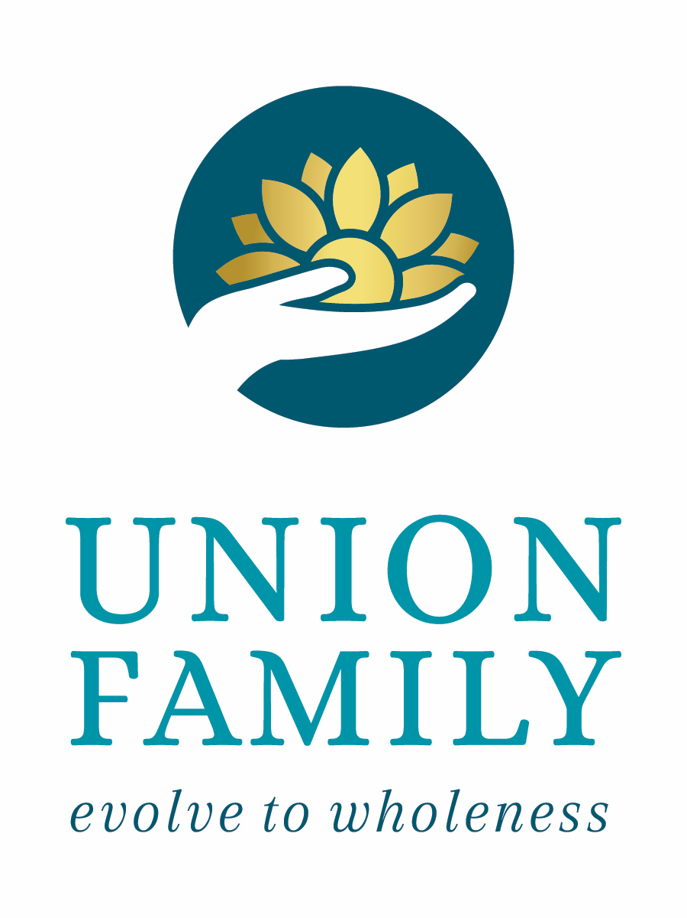

124 Winchester Ave, Suite A
Monroe, NC 28110
Phone: 704-931-8371
Fax: 877-259-6224
ufs@unionfamilyservices.com
unionfamilyservices.com

CLIENT ELECTION TO SELF-PAY FOR SERVICES

I, _______________________________________, the undersigned client, acknowledge that I understand and agree that:

Union Family Services, PLLC is a participating with__________________________
I am covered by ___________________________________________ Insurance plan
- Despite the above, I do not wish for Union Family Services, PLLC to submit a claim to my insurance company for services provided to me by
Union Family Services, PLLC.
- Until such time as I may otherwise advise Union Family Services, PLLC in writing, I elect to pay for all services I receive from
Union Family Services, PLLC at their out of pocket rate.
- By election to self-pay for services, any payments I make to Union Family Services will not be credited toward satisfying any deductible I may be subject to under my health insurance plan unless otherwise permitted under the terms of my health plan.
- I have read this Election to Self-Pay for Services form and have had the opportunity to ask any questions I may have had about the form. Any questions I may have had about this form have been answered to my satisfaction.
- I have freely chosen to self-pay for services after having asked Clinic about payment options and having carefully considered those options.

Date: ________________________________ Signature___________________________

